**Newsletter No. 27 Spring 2022**

Our Core Value for this half term is ‘***to give’***

Our Christian value for this half term is ***‘peace’***

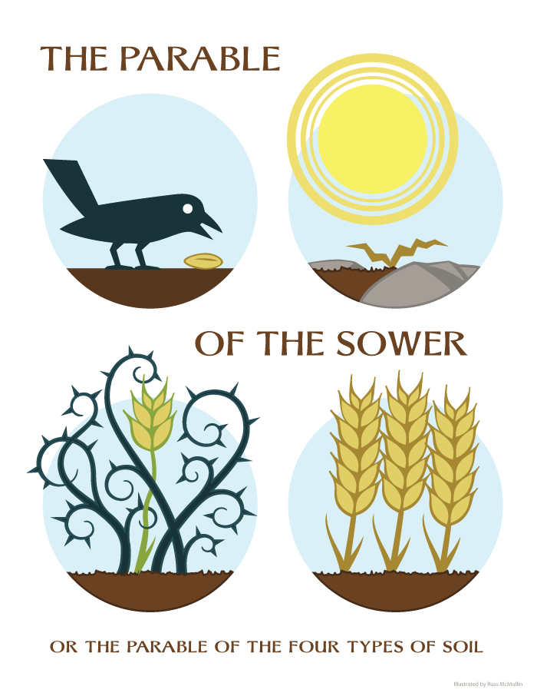

**Collective Worship:** This week, we have been focusing on the parable of the sower, our linked parable to our vision and values. The children have been learning about what the parable means and how we can be guided by this in life. The parable teaches Christians to listen to God’s message and this will help them to grow and flourish into citizens of the world.

**Vision & Values Week (This Week!)**

This first week back we have been focusing on looking at our values and our vision with the children. We have been preparing some artwork linked to the Parable of the Sower. **This artwork will be displayed in the church as part of the Barningham Jubilee Weekend**. We have also been creating displays in the hall about what our values mean to us. Each class will be creating a display in the hall and presenting it in Collective Worship next week as follows:

**Rabbits & Squirrels:** What does **being kind** mean to us?

**Badgers**: What does **giving** to others mean to us?

**Owls:** What does **being ambitious** mean to us?

Each class will also be taking part in an ‘act’ to demonstrate their value of focus as detailed below:

**Rabbits & Squirrels:** An act of kindness **Badgers**: An act of giving **Owls:** An act of ambition

**The Queen’s Jubilee at Barningham**

In all the children’s book bags today is a printout of the **plans in the village for Barningham Jubilee Weekend**, celebrating the Queen’s reign. There is also one attached to the newsletter this week. There are so many things happening between **3rd June and the 5th June** from lunch on the meadow, open gardens and cream tea to a display of flowers and children’s artwork in St Andrew’s church. It is a wonderful opportunity to bring the community together to celebrate.

At school, **we will be hosting our own Queen’s Jubilee Day on Friday 27th May 2022**. All children can come to school on this day wearing blue, white and red. They will be taking part in activities relating to the Queen and her reign as well as producing some more artwork for the Church, ready for the Jubilee Weekend.

Don’t forget, that the **Friends are hosting a Jubilee Afternoon Tea** on Friday 20th May at 2.30pm at the school as well!

**Sports Days**

We currently buy into specialist Sports and PE lessons in our school through Premier Sports (KS2) and the Thurston Sports Partnership (KS1/EY). This year, they will be running our Sports Days on the cricket meadow. **We can finally welcome parents to come and support their child during their sports days**. I wanted to give you the dates as soon as possible so you are able to attend. I will let you know exact times once these are confirmed.

**Wednesday 13th July:** Rabbits and Squirrels (EY/KS1) Sports Day (am) Timing TBC

**Thursday 14th July:** KS2 Sports Day (Timing TBC)

******Friends of Barningham Update**

Hi everyone, we would like to thank everyone for supporting us at the donut sale on the last day of term where we sold out. We have our next donut sale tomorrow Friday 29th April 3:20 in the playground costing 50p each. Thank you to all who supported our fundraising last term; with the Easter Coffee Afternoon, donut sale and generous donations, we raised an amazing £272 for the school as part of our fundraising efforts to buy interactive whiteboards. Please keep a look out for all our latest news on the Friends of Barningham School Facebook page:

<https://www.facebook.com/FriendsBarninghamSchool/>

**Friends of Barningham School**

**COVID-19 Update (please note change in new guidance!)**

In total up to and including today, **we now have 1 ‘live’ positive case within the last 10 days.**

**New guidance has now been released** and I have summarised this below. This guidance is in place from 1st April 2022:

* **All LFD testing has been suspended** for education settings – this includes pupils and staff.
* **Children / Staff are no longer recommended to get tested** for COVID-19 unless directed by a health professional
* Adults and children are now recommended to **attend school if they are experiencing mild symptoms** **and** they are feeling well enough e.g. runny nose, sore throat, or slight cough
* **Adults and children who are unwell and have a high temperature** should stay at home and avoid contact with other people, where they can, they can resume normal activities when they no longer have a high temperature and are well enough to attend
* Although legal requirement to isolate has ended, **adults and children who test positive** will continue to be advised to stay at home and **avoid contact with other people for at least 5 full days for adults** and **3 full days for children**, if they can after they took the test.
* **Remote learning will no longer be provided** for pupils who are isolating at home due to being unwell or having a temperature as guidance above indicates. This is because these pupils will be too unwell to come to school and therefore too unwell to complete remote learning. Remote learning will only be considered in exceptional circumstances and this is at the discretion of the school and decided on a case by case basis.

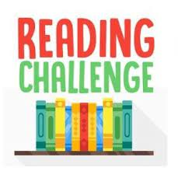

**Reading Challenge**

Our aim is to promote a love of reading for all children in our school by encouraging the habit of reading daily. We are asking all children to read at home daily. All reading records will be checked in school every Friday. **Children who have read at home, 7 days, for that week will be awarded a certificate in our Celebration Assembly as well as a ticket to be entered into a whole school prize draw to win a book** **weekly.**

**Uniform**

A reminder that the **new uniform policy has now started but will come fully into place in September 2022.** This will allow families to have the year to move from navy trousers/skirts to black and to purchase new uniform when their child grows out of their old uniform. A summary of the main uniform changes are below:

* Children will wear black bottoms (skirts, trousers, shorts, jogging bottoms on PE days)
* Jumper/cardigan remains navy with the school logo
* Ties will no longer be part of the school uniform from September 2022
* School PE kit will have the red PE t-shirt with logo, black jogging bottoms/shorts and plain all black trainers.

Thank you to all the parents for your commitment in ensuring children are dressed smartly to come to school.

***Please remember to put your children’s names on all items of clothing so that we can return any lost property to their rightful owner.***

**Breakfast Club**, which opens at 7.45 every morning and costs just £4 per session, **payable when you drop off** please or via the SchoolMoney app.



**After School Club** is open for five nights a week until 4:30 and it is £4 a session. We provide a snack, games and friendship. We’d love to see you there! Please book in advance through the school office.



**House Points: Blue 1037    Yellow 902** **Red 934**

**Blue** team are in the lead!

**Key Dates for your diary: (Please note new dates in red/changes in red)**

**Friday 29th April 3.20pm** - After School Donut Sale

**Tuesday 3rd May:** Parent information session for Y6 SATs with Mr Rolfe at 3.30pm in Owl Class

**Monday 9th May – Thursday 12th May:** Year 6 SATs (Y6 children invited to breakfast club)

**Wednesday 11th May:** Friends Meeting at Village Hall at 9.15am

**Friday 20th May 2.30pm til 4pm** - Jubilee Afternoon Tea

**Friday 27th May:** Queens Jubilee day at school. Children can wear red, white and blue to school.

**Friday 27th May 3.20pm** - After School Donut Sale. Last day at school for the children – Half term begins

**Friday 3rd June:** Barningham village event on the Cricket meadow for the Queen’s Jubilee

**Saturday 4th June:** Barningham village event including open gardens and cream tea at the Village Hall

**Sunday 5th June:** Barningham village event service led by Reverend Cathy at Barningham House

**Friday 3rd June – Sunday 5th June:** Children’s artwork available to view in St Andrew’s Church

**Monday 6th June:** Staff Training Day PD Day – new phonics scheme called Read Write Inc

**Tuesday 7th June:** Children return to school

**Friday 10th June 3.20pm –** Ice Cream Fridays return every Friday after school

**Saturday 9th July 1-3pm** - Summer Fayre

**Wednesday 13th July:** EY/Y1 and Y2 Sports Day (am) Timing TBC

**Thursday 14th July:** KS2 Sports Day (Timing TBC)

**Friday 15th July** School Disco

**Thursday 21st July:** Last day of school for the children – Summer holidays begin

**Did you know that there are TWO ways you can support your school every time you do an online shop 🛒🥰?** It costs you absolutely nothing, but the charity budgets from these large corporations will donate a few pence straight to us with each transaction

**Amazon Smile:** Next time you shop at Amazon, login at [https://smile.amazon.co.uk/ch/1030812-0](https://smile.amazon.co.uk/ch/1030812-0?fbclid=IwAR11YdDo77RKpxs919IIZEi3lR1zkRfktBHrmcYJ32bA7O7m5UAyI1JIKaI)

[**Easyfundraising.org.uk:**](https://l.facebook.com/l.php?u=http%3A%2F%2FEasyfundraising.org.uk%2F%3Ffbclid%3DIwAR01RZkvrL7-mH8jmONq30qWU4JGTxcZhwEH3KptS9RZ-RZaRakdnopgP3I&h=AT3TiDd4h_TgN0rWIW9Mr6OvXovbkxeHX5NVXMH_dvTV2IB8qwco_1FL4MBvF-BWq_T4Gi7bOO3LQ6gTwf9tAkVpc7N-cRmvmQb7iP2IGgnYR-f-nzu2pvL8ZQHRQobYWoTRlBYW-m_JHxPgwA&__tn__=-UK-R&c%5b0%5d=AT3ah9cMb5Zw8h1DTT5gxnL756U1nidelmtBKCKpAWX5zd-VAo5oFybgpgICclmKIm7DwwEJfAKrwNyfW6SVb0UaB3qrV4N_mZbyi2LY9pe6feRQwZ4EgeY8qMLZNPFfRa2_wC6_bwb0Uvh3uVkVcNOVmfv4oaSSSUSTeM_A1tfkuwVw0kFg-q7FEyD5mYFux6FT9AZI) By signing up to easyfundraising online, everytime you purchase something from one of over 3,000 retailers, including M&S, Argos, eBay, Tesco etc, a small percentage of what you spend will be credited to our account. To register for an account, go to [https://www.easyfundraising.org.uk/causes/fobcevcps/](https://www.easyfundraising.org.uk/causes/fobcevcps/?fbclid=IwAR3xBNj6ZwqwZJl_drxUb8lEj-vs25wexReWc7ZSu7JCu4DgCO13f9pmTws)

Thank you for your continued support, **The Friends of Barningham School**



**"A note from the Governors:**Welcome back everyone, we hope you enjoyed the Easter break and had some fun family times together.  We wish all the children and staff a happy and productive summer term, and we look forward to seeing the children getting involved in more outdoor sporting activities as the weather warms up.    As Governors, we have a vacancy for a Co-opted governor.  If you have experience that would support our Governing Body, please get in touch with me to discuss at[barninghamgovernors+julie@gmail.com](mailto:barninghamgovernors+julie@gmail.com)  **Julie Surridge, Chair of Governors."**

**Twitter**

Come and have a look at some of the great work happening at school by clicking on this link <https://twitter.com/BarninghamCEVCP> . Also, **You can follow us on @BarninghamCEVCP.** If you can ‘like’ or ‘retweet’ our tweets, it helps to get the school some positive attention.

Our Class Pages are up and running and you can find them here:

@BCEVCPOwls <https://mobile.twitter.com/BCEVCPOwls>

@BCEVCPBadgers <https://mobile.twitter.com/bcevcpbadgers>

@BCEVCPSquirrels <https://mobile.twitter.com/BCEVCPSquirrels>

@BCEVCPRabbits <https://mobile.twitter.com/bcevcprabbits>

If you haven’t got a twitter account, you can follow instructions here <https://www.wikihow.com/Make-a-Twitter-Account> . Then once you have an account, you can follow us on @BarninghamCEVCP or your child’s class as above (or both!).

Why not look on our **school website** ([www.barningham.suffolk.sch.uk](http://www.barningham.suffolk.sch.uk) ) for more information, newsletters and policies.

Stephany Hunter

Headteacher

**We grow in faith, grow in our learning and grow our future world**

Barningham CEVC Primary School is committed to safeguarding and promoting the welfare of all children. The Designated Safeguarding Lead is Miss Hunter, the Alternate Designated Person is Mrs Pipe and the Governor with responsibility for Safeguarding is Mrs Kurtz.

The Online Safety Lead is Mrs Smithson and the Governor with Responsibility for Online Safety is Mrs Kurtz

[](http://www.healthyschools.gov.uk/Default.aspx)    

SUFFOLK COUNTY COUNCIL