Maths Content Sequencing at Barningham CEVC Primary

Early Years – Autumn Term

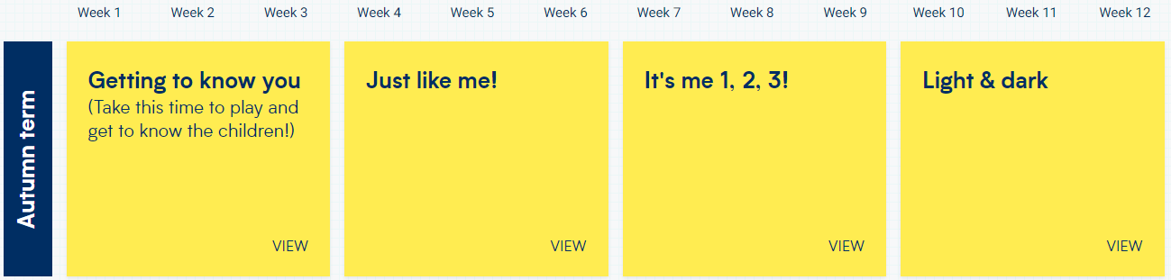

Early Years – Spring Term

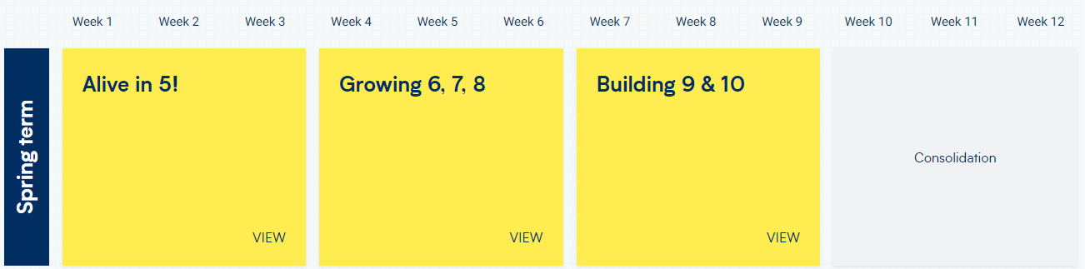

Early Years – Summer Term

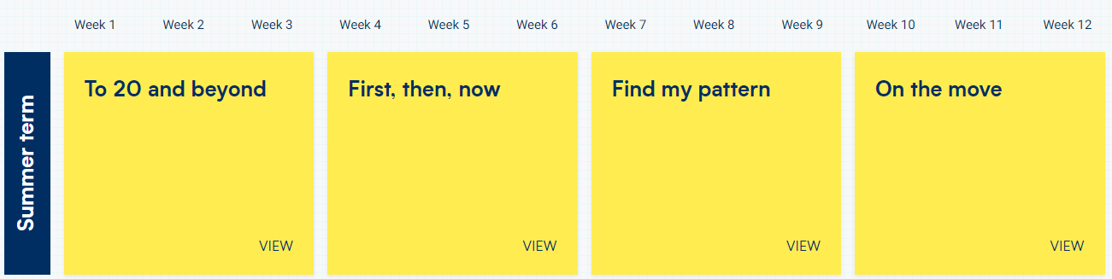

KS1 – Autumn Term

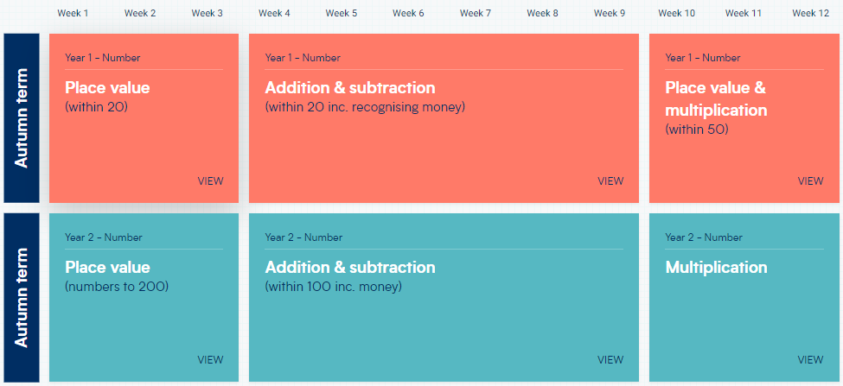

KS1 – Spring Term

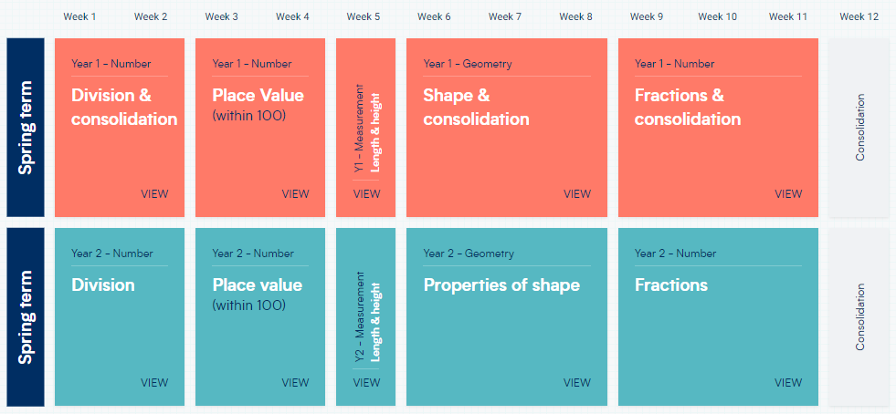

KS1 – Summer Term

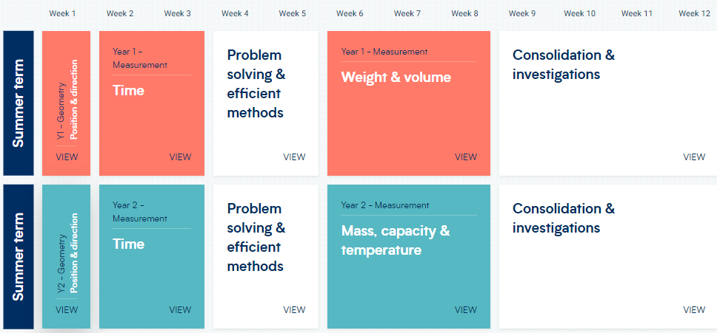

LKS2 – Autumn Term

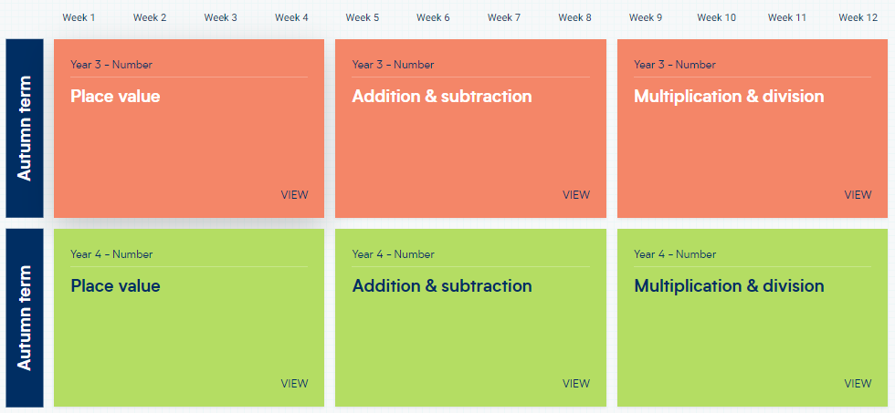

LKS2 – Spring Term

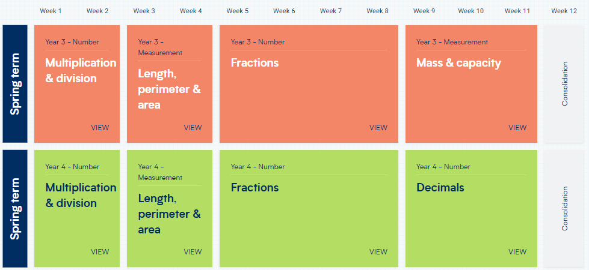

LKS2 – Summer Term

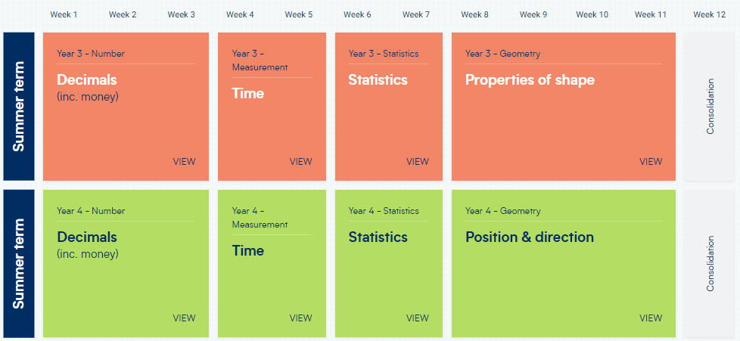

UKS2 – Autumn Term

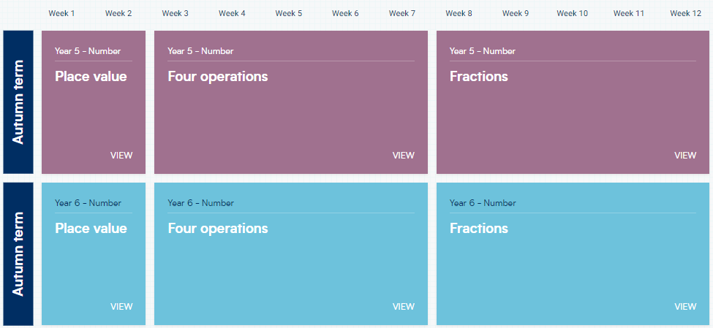

UKS2 – Spring Term

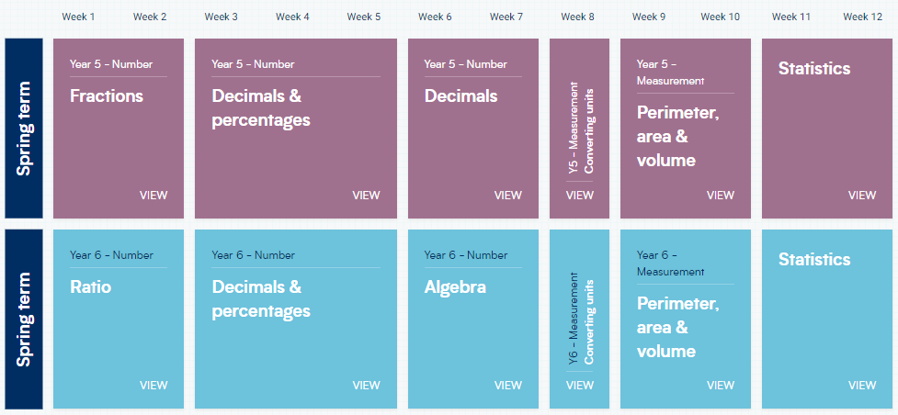

UKS2 – Summer Term

